Summary

A CCTV survey was carried out on Littleton Borehole (site ref 782.1) on the 26th June 2019.

In addition; conductivity and temperature probing, a calliper survey and sampling of water within the borehole was undertaken.

Immediately prior to the survey, water level was manually dipped at 126.6 mbgl. This was confirmed by the CCTV survey as 126.58 mbgl.

Water samples were taken at depths of:

* 131.6 mbgl
* 162 mbgl
* 200 mbgl

Sample depths were decided based on casing levels, along with results from the conductivity and temperature probe.

The samples were tested both on site by an STS operative and in the UKAS accredited laboratory at SOCOTEC Ltd. (See laboratory UKAS report reference W28_6268).

The intention was to survey the borehole down to the original drilled depth of 233.8mbgl. However, a blockage was encountered in the borehole at 202.1m which the camera/probes could not progress past. This coincides closely with the recorded base of steel casing at 202.70mbgl. Thus, the lowest ~20m unlined, open hole, section of the borehole could not be surveyed.

The calliper survey confirmed an average casing internal diameter of 156.5mm from surface down to the blockage.

The results of the survey are presented in Figure 1 to Figure 7.

Chemistry

Water was encountered in the shaft at approximately 126.6mbgl. All the key parameters tested showed two step changes within the water column, at ~156mbgl and 169mBGL. A summary of chemistry changes can be seen in Figure 2, Figure 3, Figure 4 and Figure 5.

* Conductivity was seen to increase by approximately 28,000µS/cm
* Temperature showed only a slight increase of 0.4°C (onsite discrete sample) compared to 3°C (in-situ probe)
* Chloride, sodium and calcium all showed an increase
* Alkalinity showed an increase, but only by a very small amount
* Sulphate, iron, and manganese both showed an increase and then decrease to base of survey.

|  |  |  |  |
| --- | --- | --- | --- |
| Parameter | Water layer 1 (126mbgl to 156mbgl)  At 131.6 mbgl | Water layer 2  (156mbgl to 169mbgl)  At 162 mbgl | Water layer 3 (169mbgl to 202mbgl)  At 200 mbgl |
| Iron (mg/l) dissolved | 0.45 | 5.52 | 0.96 |
| Iron (mg/l) total | 8.01 | 17.8 | 11.9 |
| pH | 6.6 | 5.9 | 6.4 |
| Alkalinity (mg/l) | 10 | 19* | 20* |
| Sulphate (mg/l) | 106 | 1840 | 1200 |
| Chloride (mg/l) | 110 | 8000 | 10400 |
| Sodium (mg/l) | 76 | 4660 | 6360 |
| Calcium (mg/l) | 44 | 433 | 549 |
| Electrical Conductivity (at 25ºC) | 639 | 22600 | 26500 |
| Temperature (ºC) (onsite testing) | 12.9 | 13.3 | 13.3 |
| Manganese (mg/l) | 0.47 | 3.76 | 2.34 |
| Ammoniacal Nitrogen (mg/l as N) | 0.4 | 5.4 | 5.9 |
| Bromide (mg/l) | <0.5 | 30.4 | 40.3 |
| Fluoride (mg/l) | 0.2 | <0.1 | <0.1 |

Notes - * The Alkalinity results appear to be very low. The suspect values were raised with the laboratory, who subsequently replied saying that they had confirmed the values.

See laboratory UKAS report for full results.

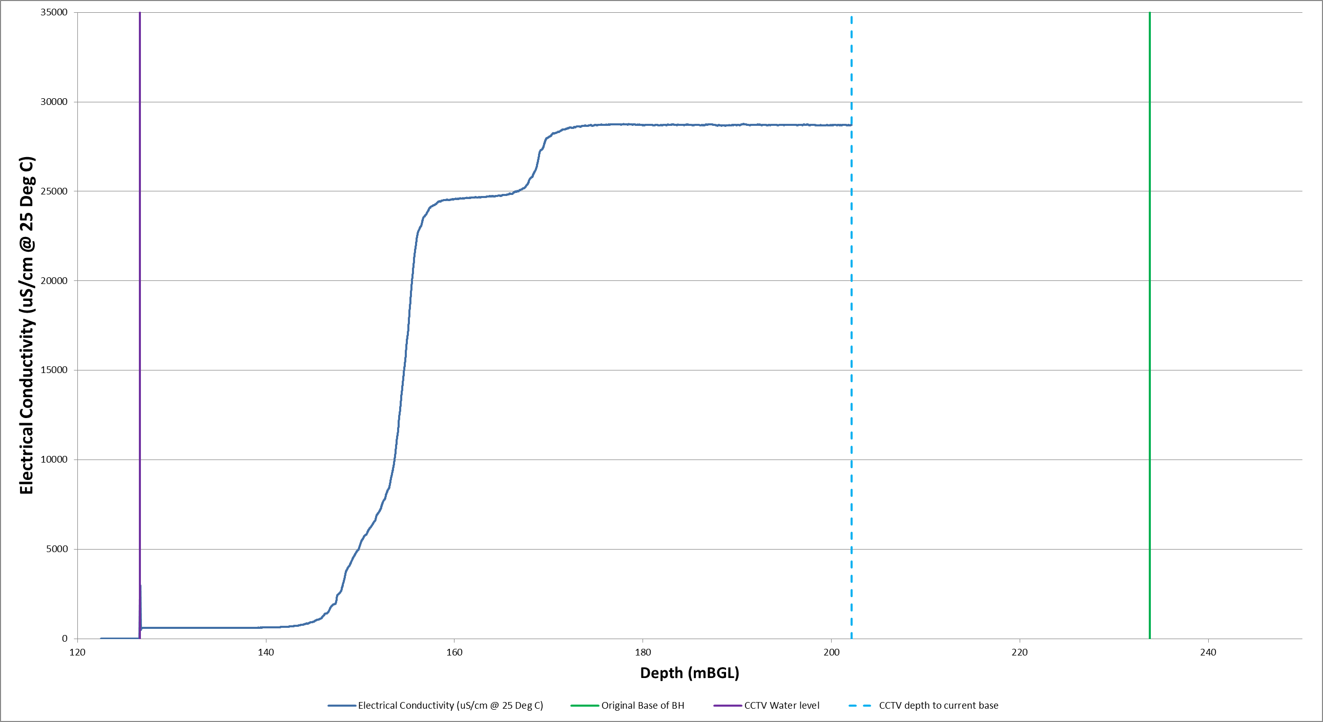

Figure Depth vs. Electrical Conductivity

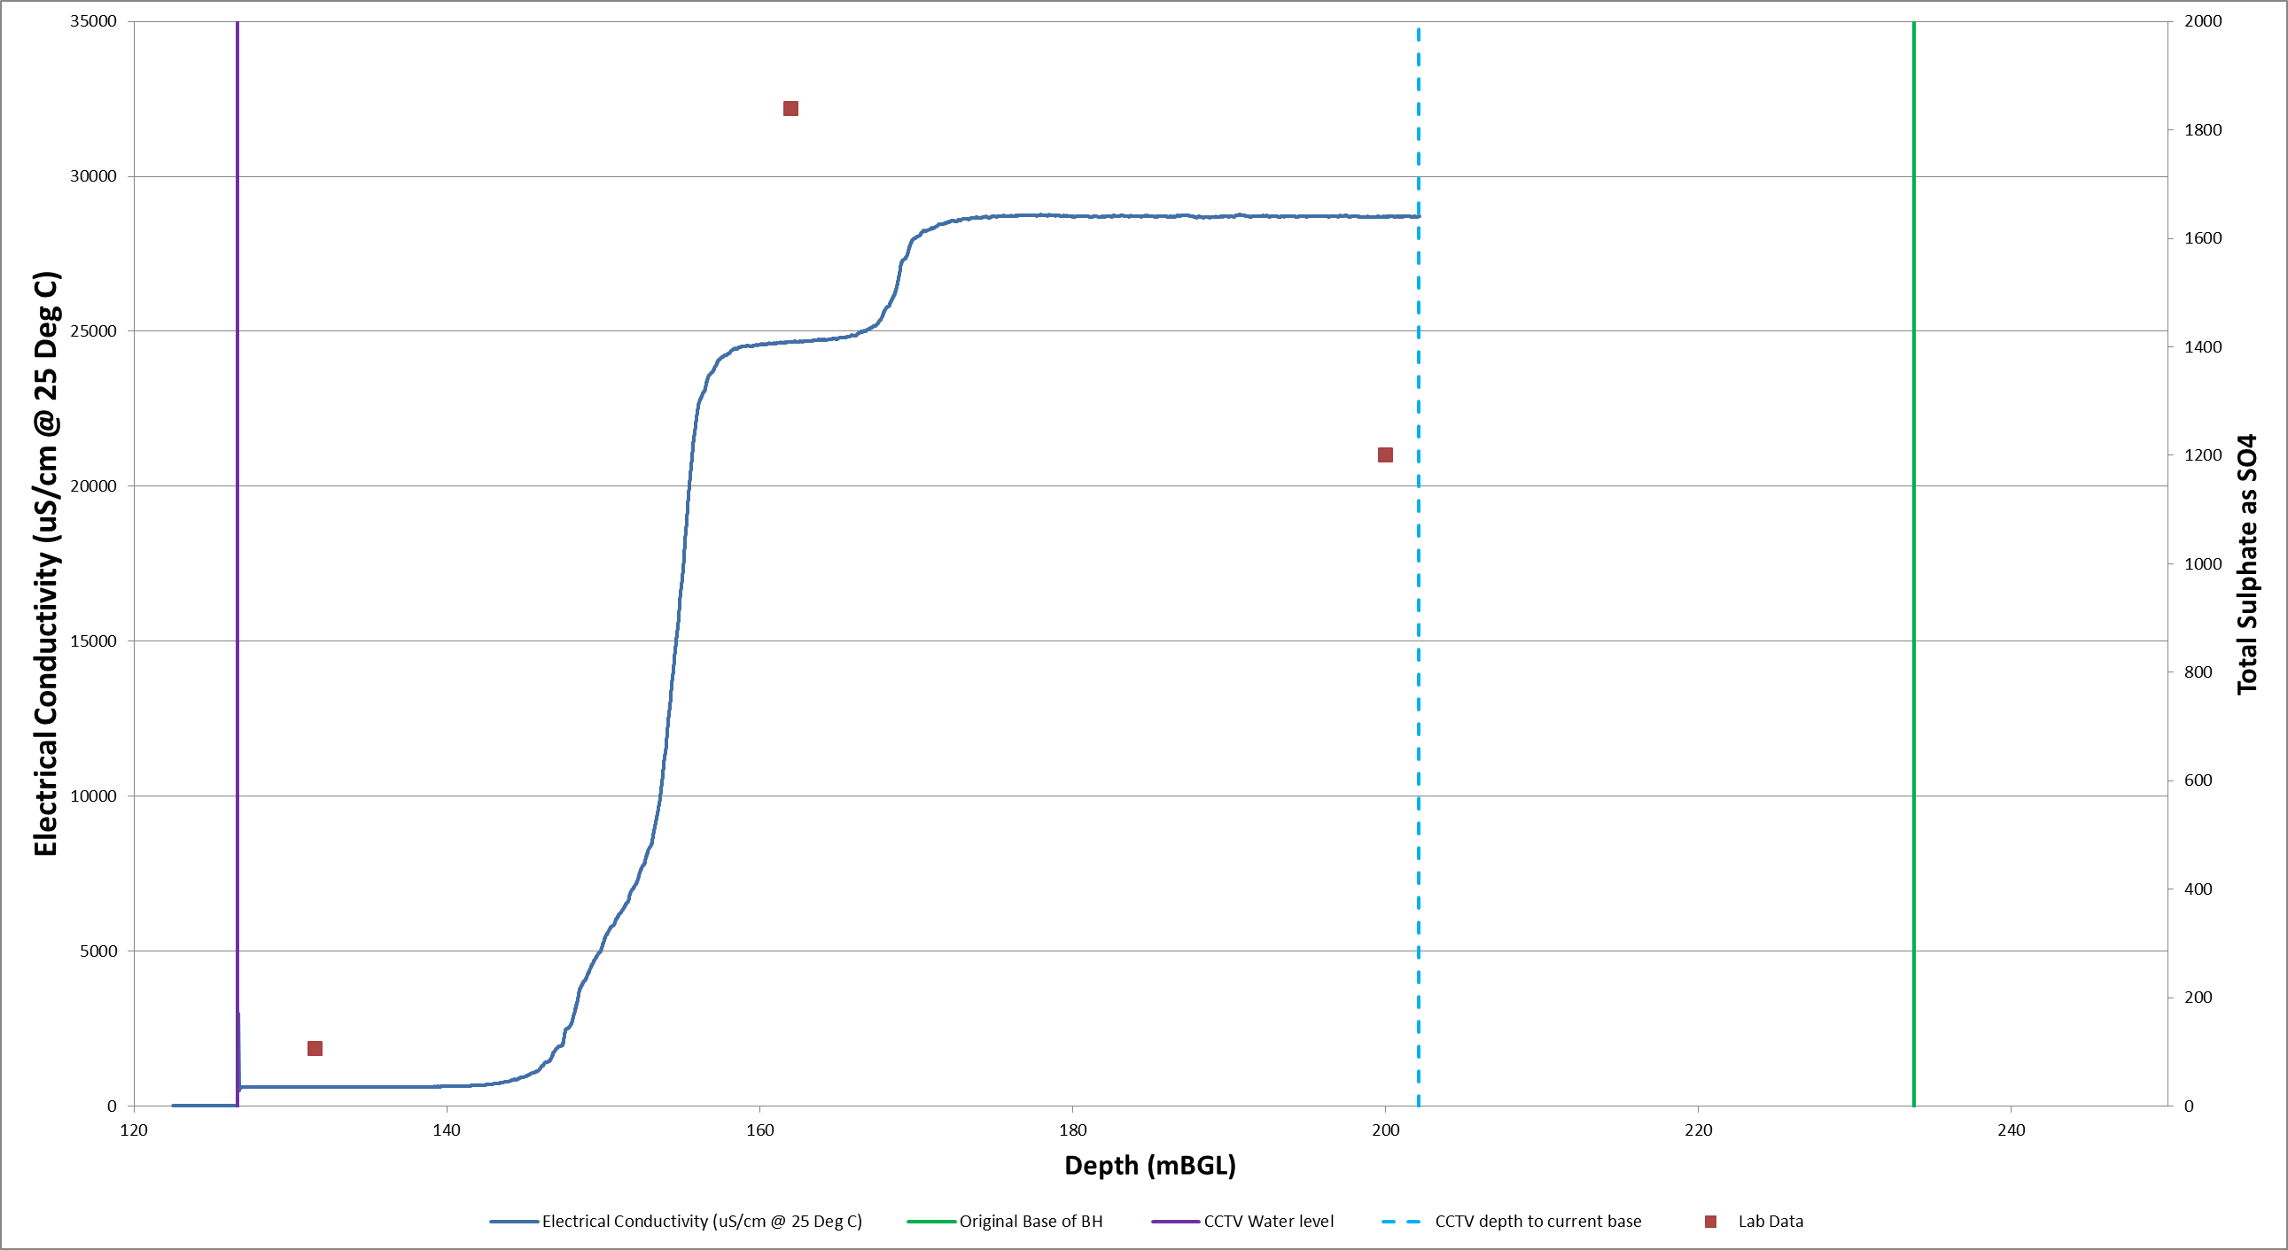

Figure Electrical Conductivity Vs Sulphate

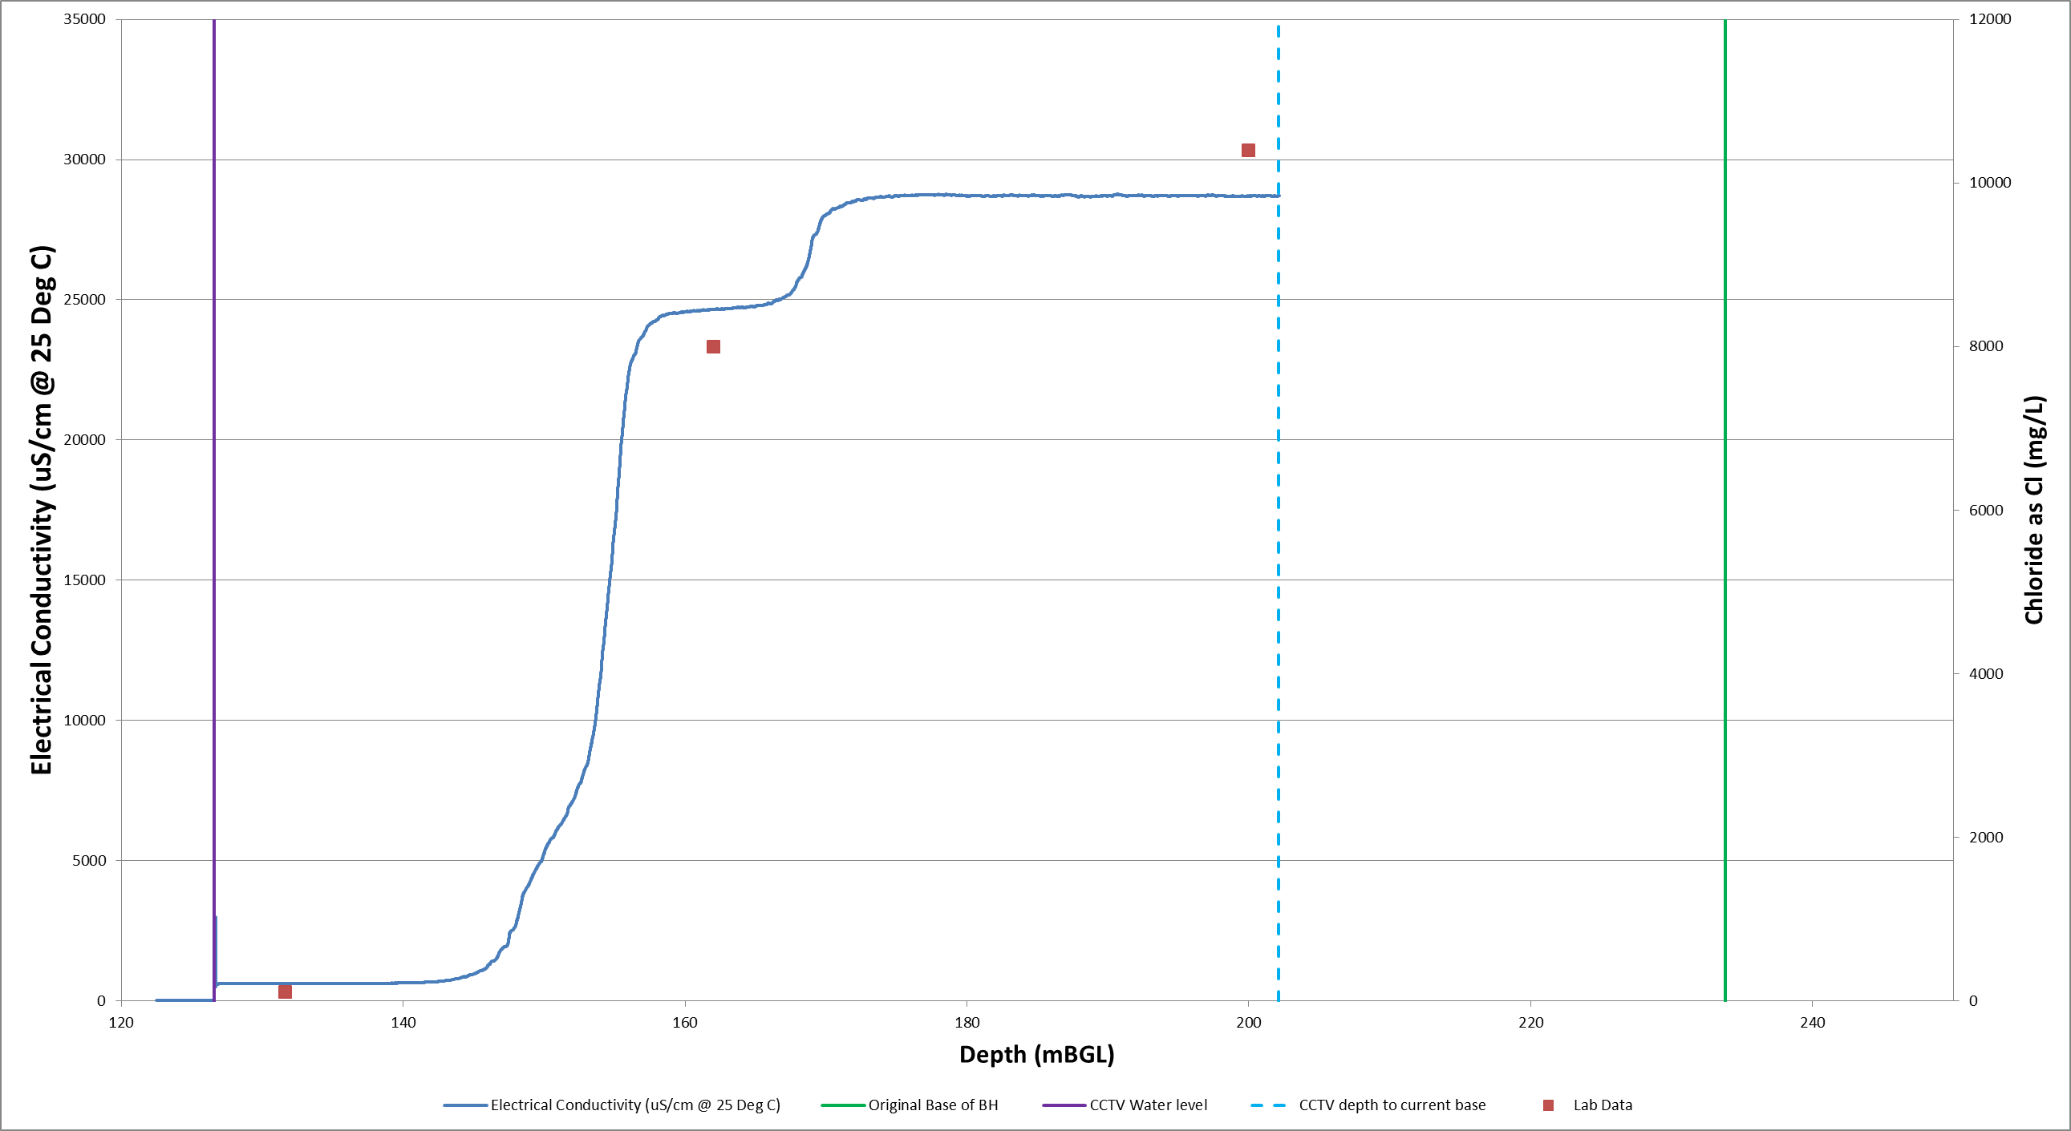

Figure Electrical Conductivity Vs Chloride

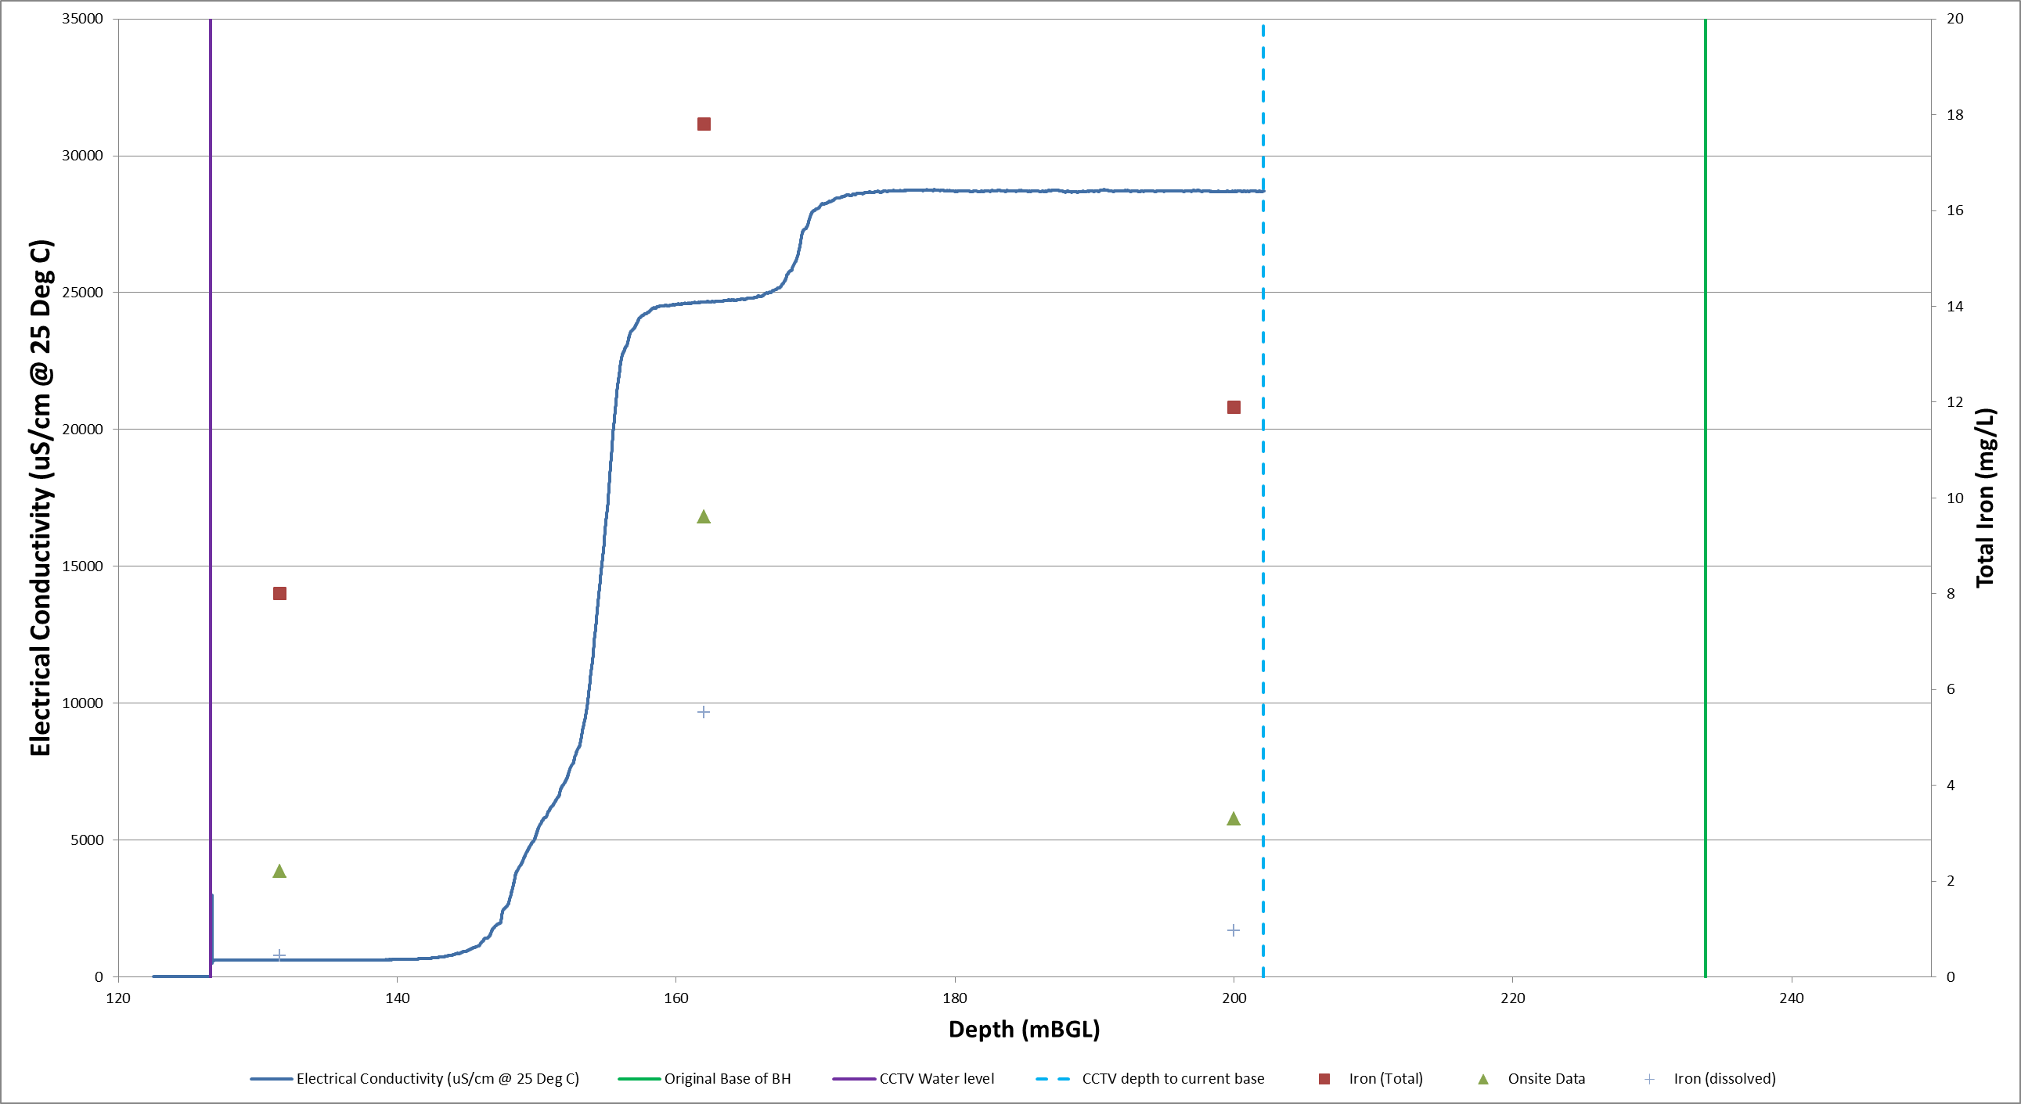

Figure Electrical Conductivity Vs Iron

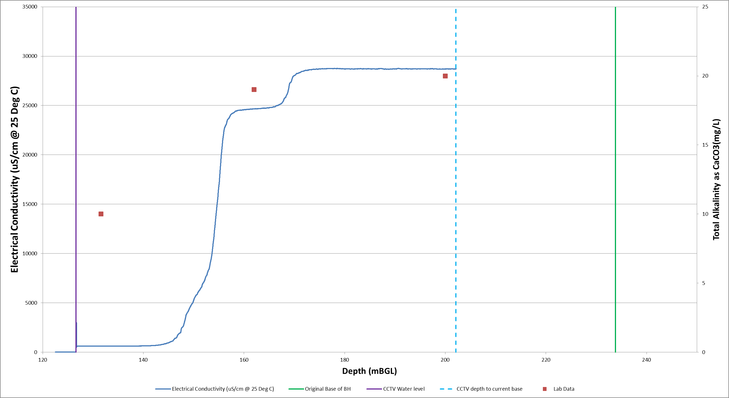

Figure Electrical Conductivity Vs Total Alkalinity as CaCO3

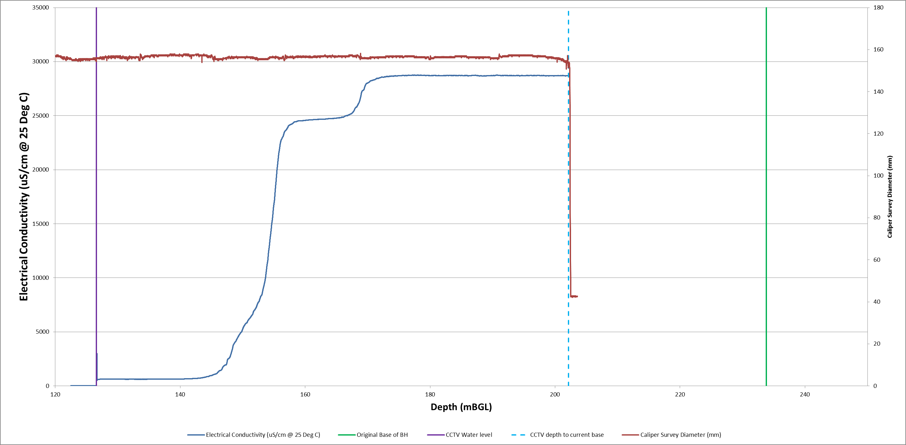

Figure Electrical Conductivity Vs Calliper Survey Diameter (mm)

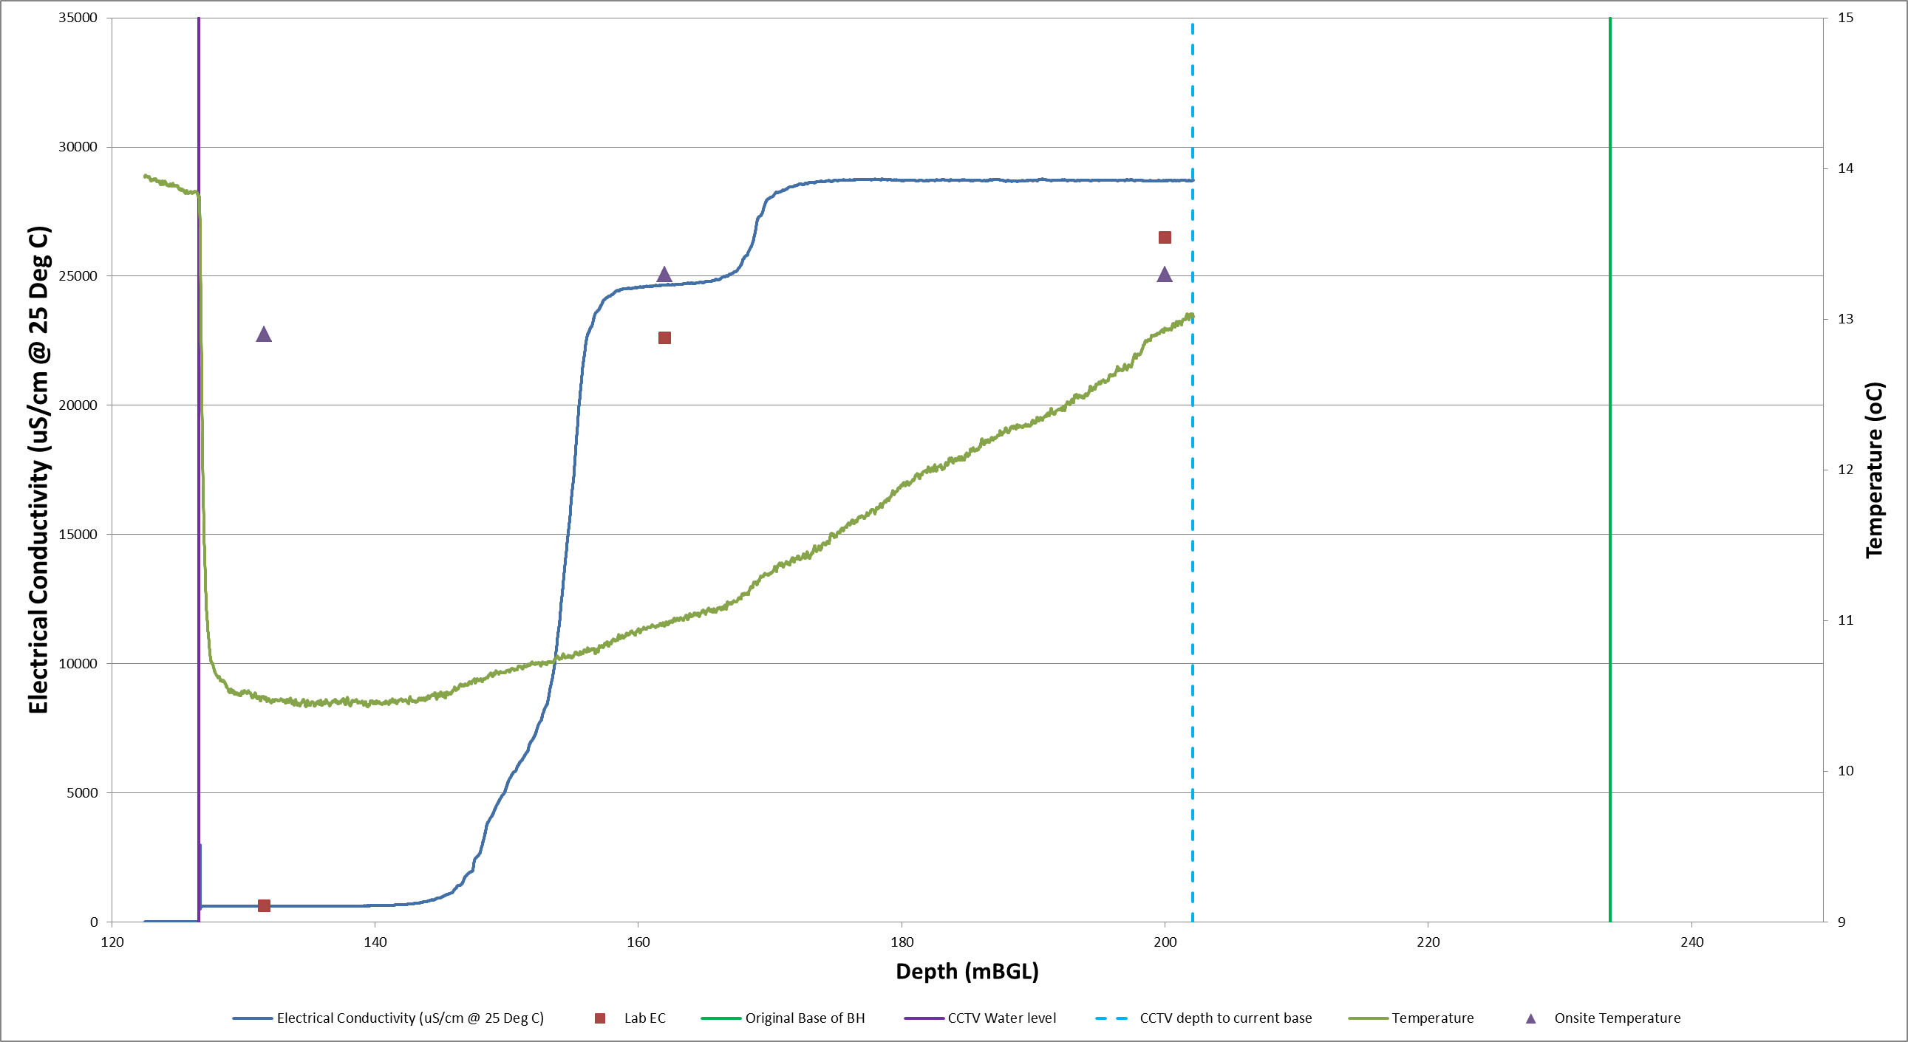

Figure Electrical Conductivity Vs Temperature

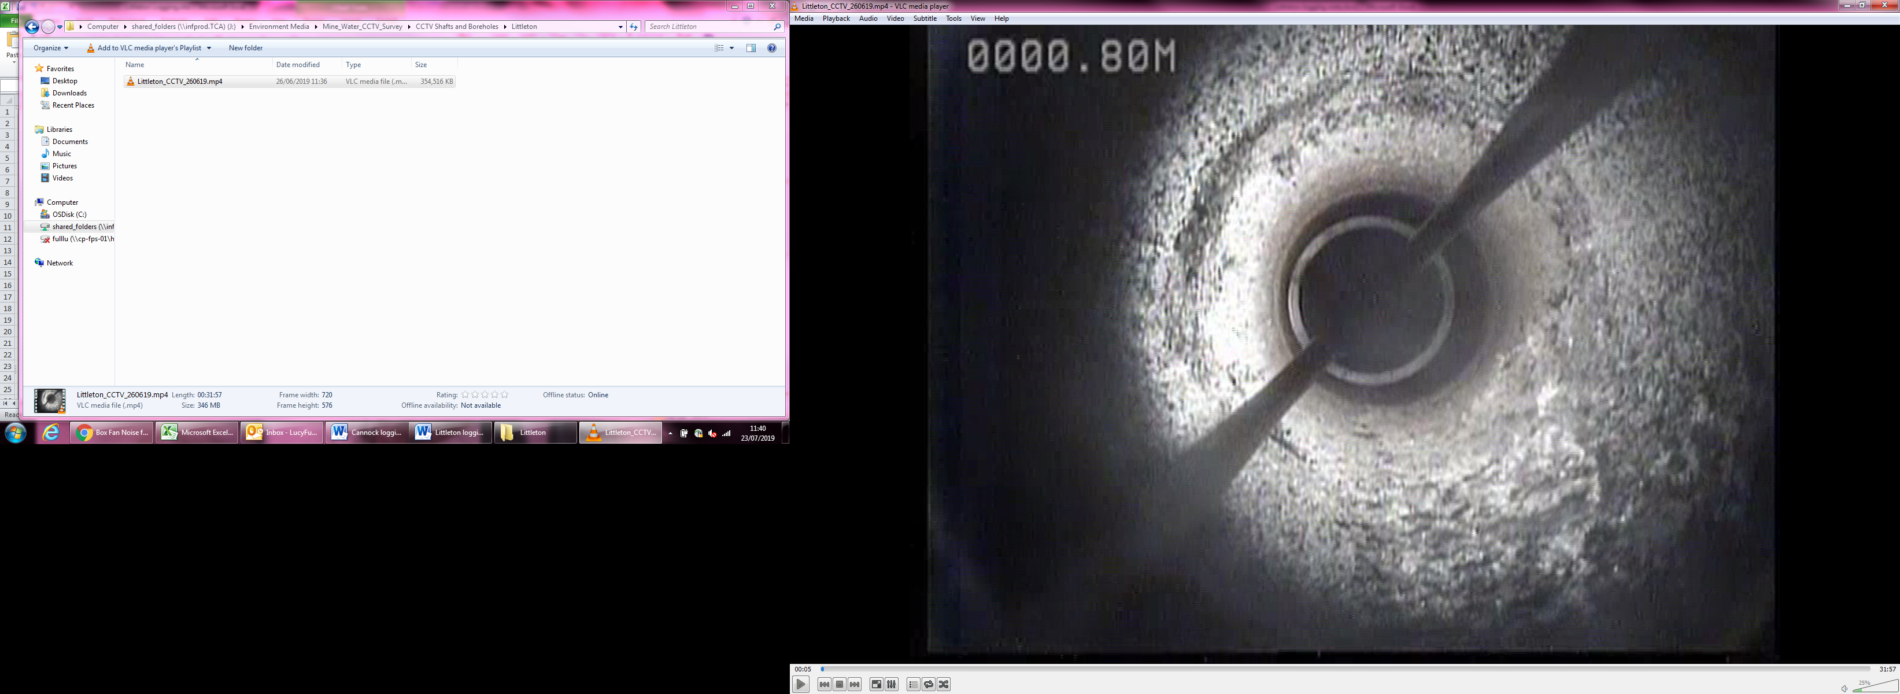

**Photo 1 Top of Borehole**

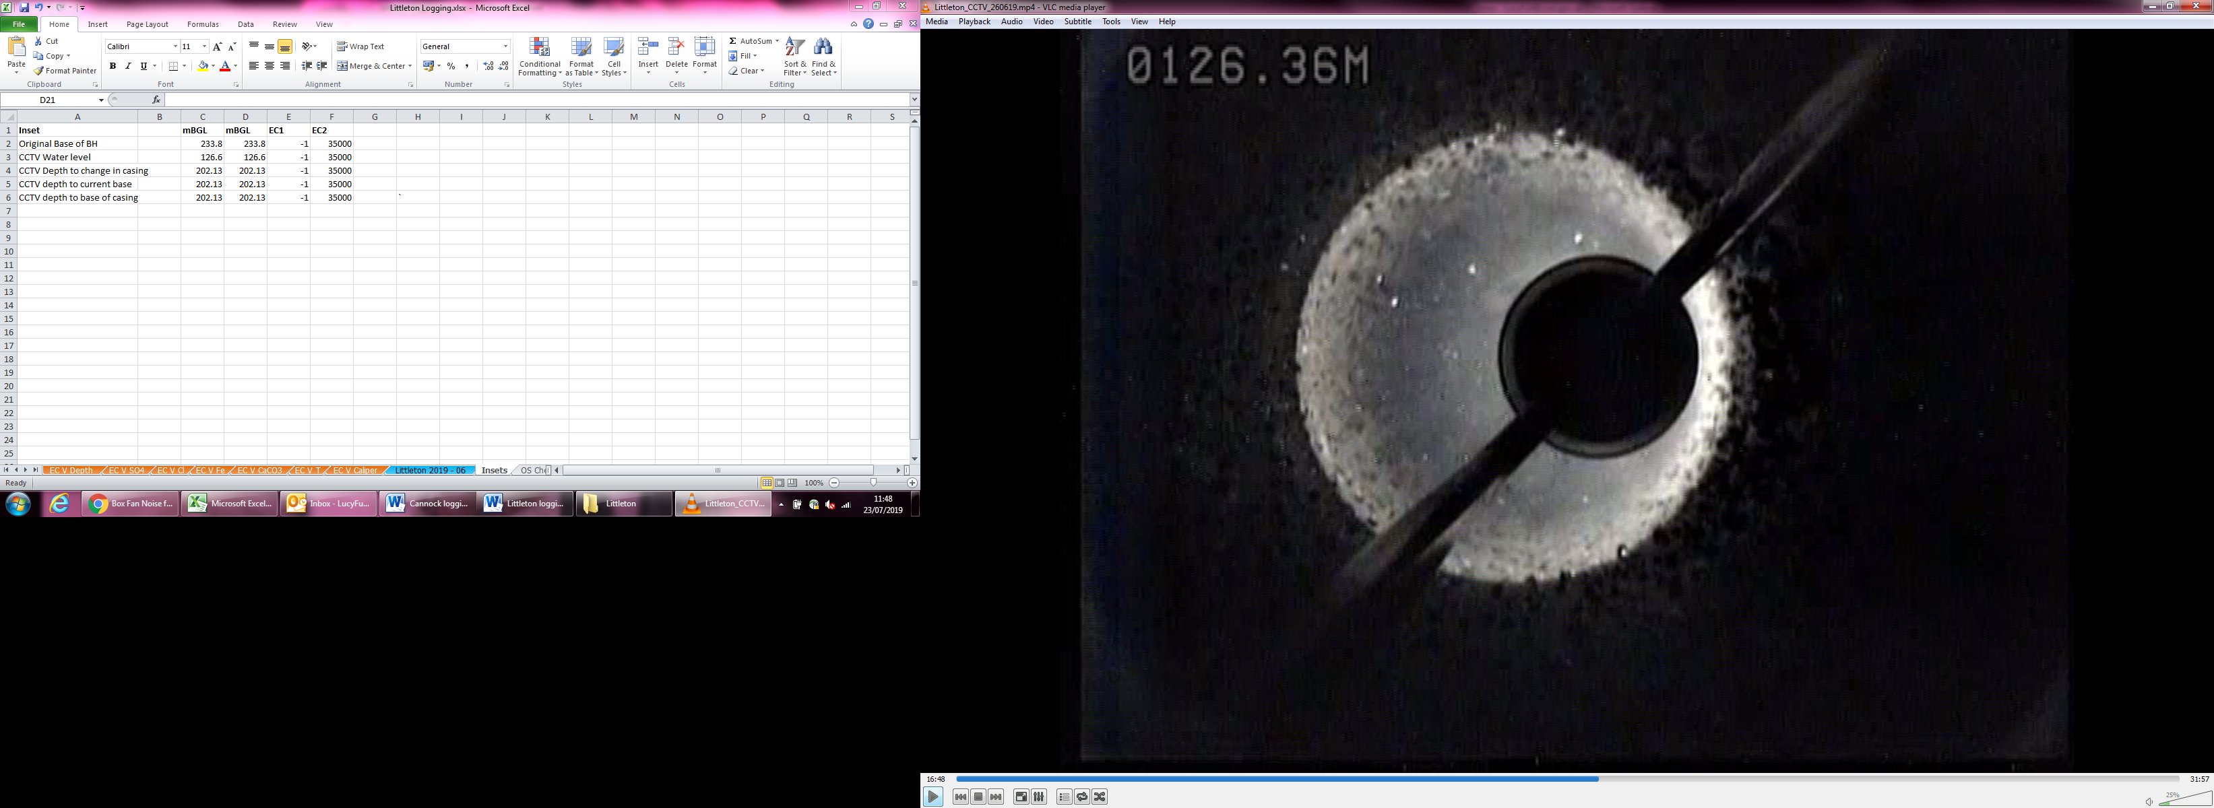

**Photo 2 Water Level**

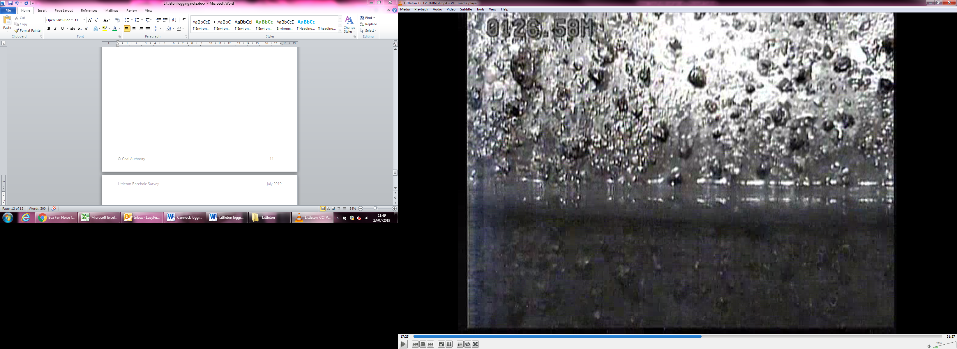

**Photo 3 Water level**

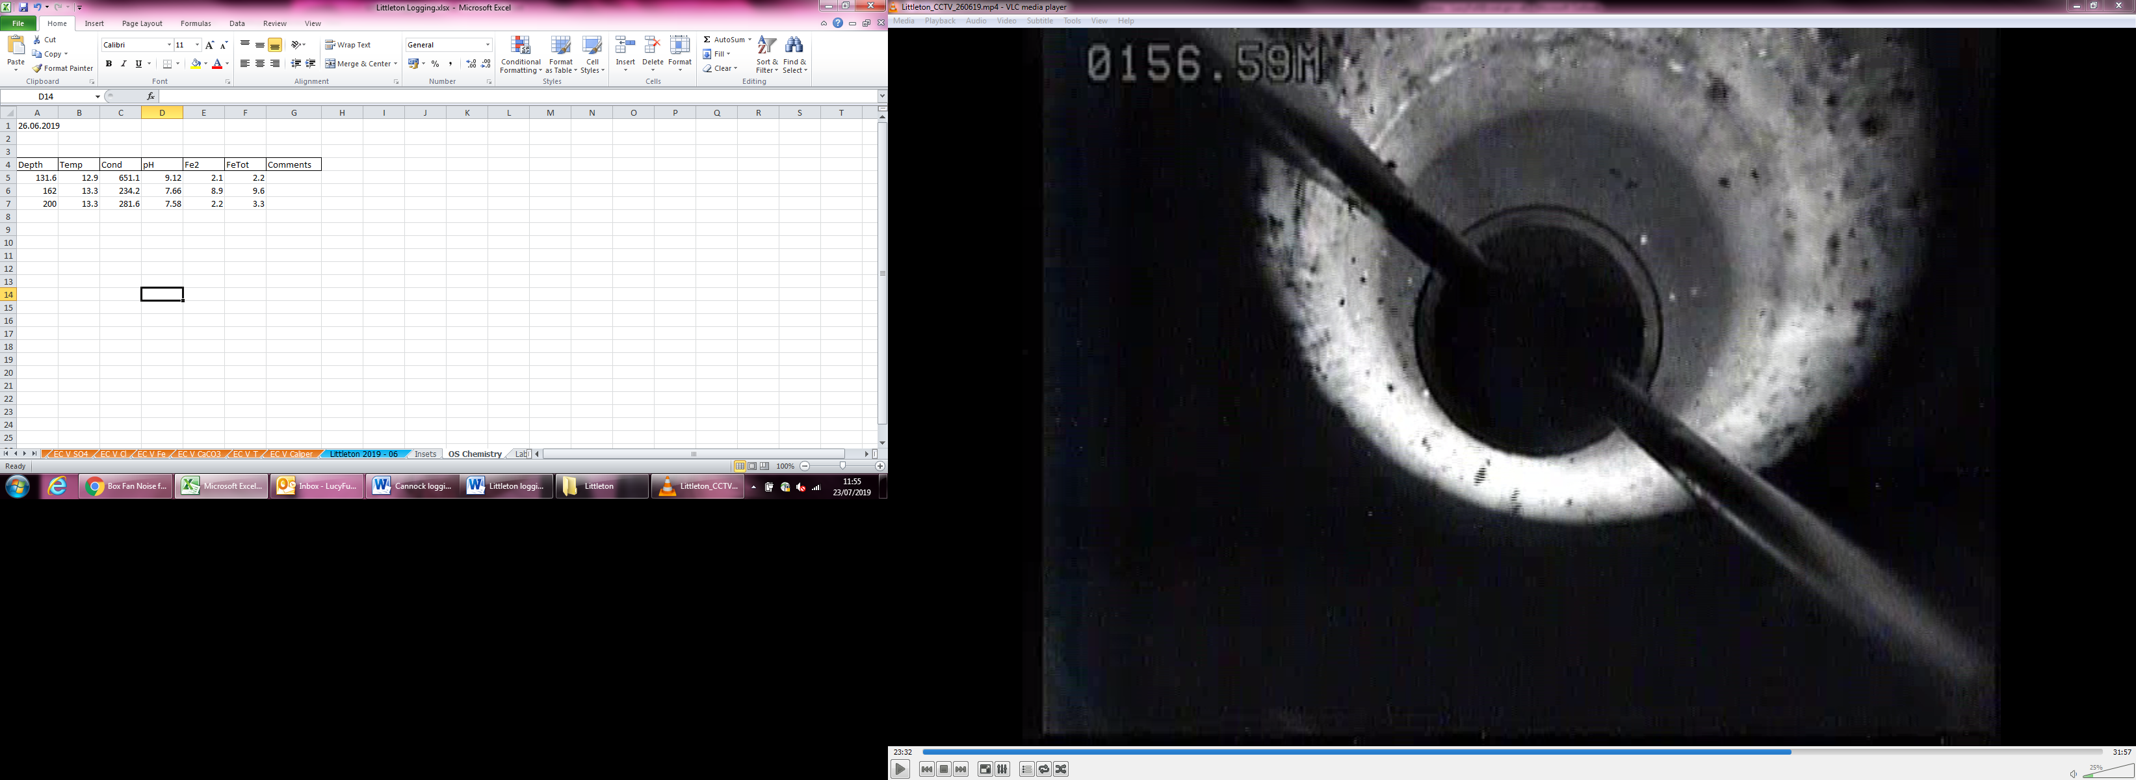

**Photo 4 Borehole at ~156m**

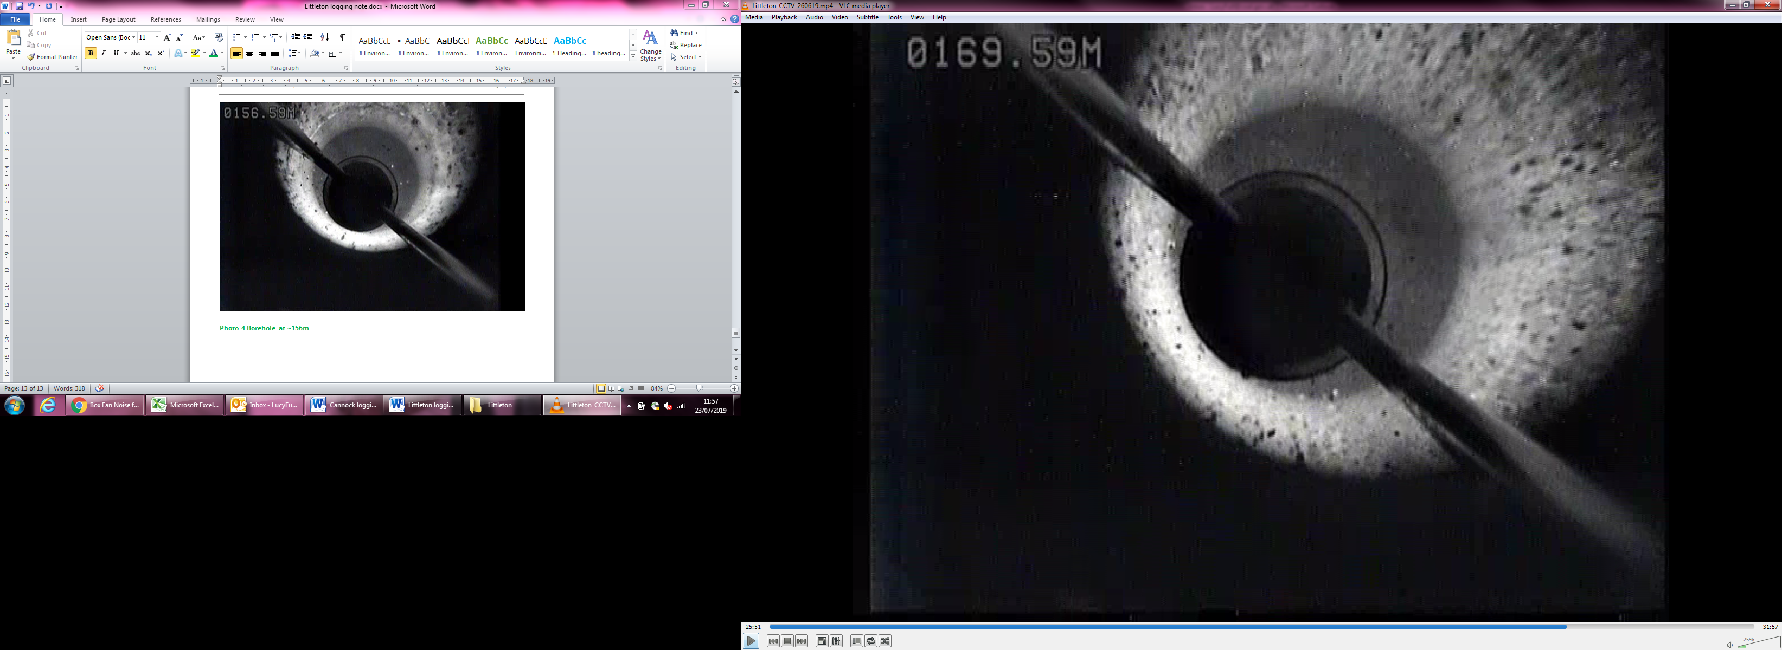

**Photo 5 Borehole at ~169m**

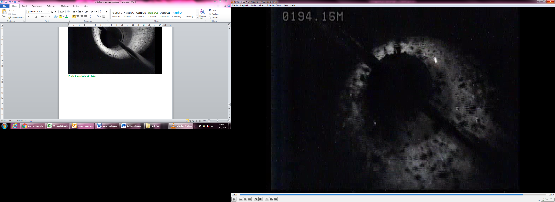

**Photo 6 Debris in borehole**

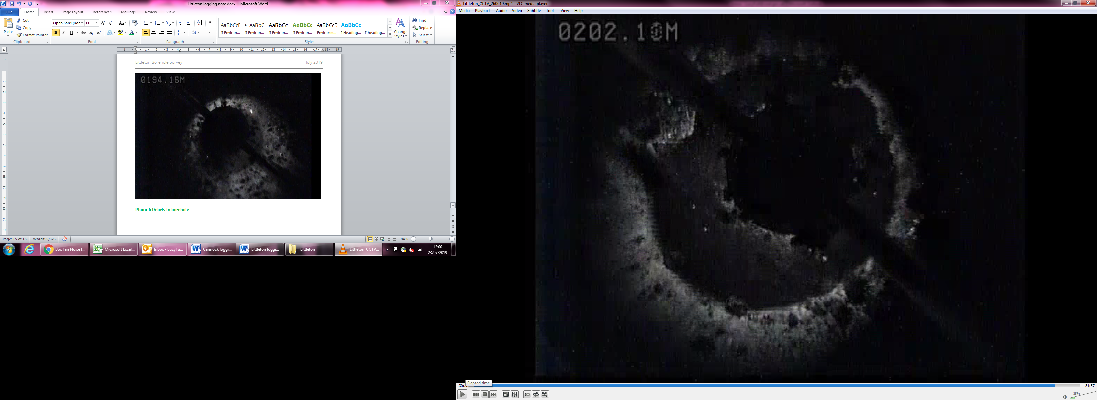

**Photo 7 Blockage at 202m**